Task 1: Your GPU Details

My system has a dual-GPU setup (a dedicated card for heavy tasks and an integrated chip for battery saving):
Primary / High-Performance GPU
- Brand: NVIDIA
- Model Number: GeForce RTX 4050 Laptop GPU (6 GB)
- Type: Dedicated GPU
Secondary / Power-Saving GPU
- Brand: Intel
- Model Number: Intel(R) UHD Graphics (128 MB)
- Type: Integrated (Shared System Memory (up to 7.8 GB from 16 GB RAM))

Task 2: Cooling System Parts & What They Do

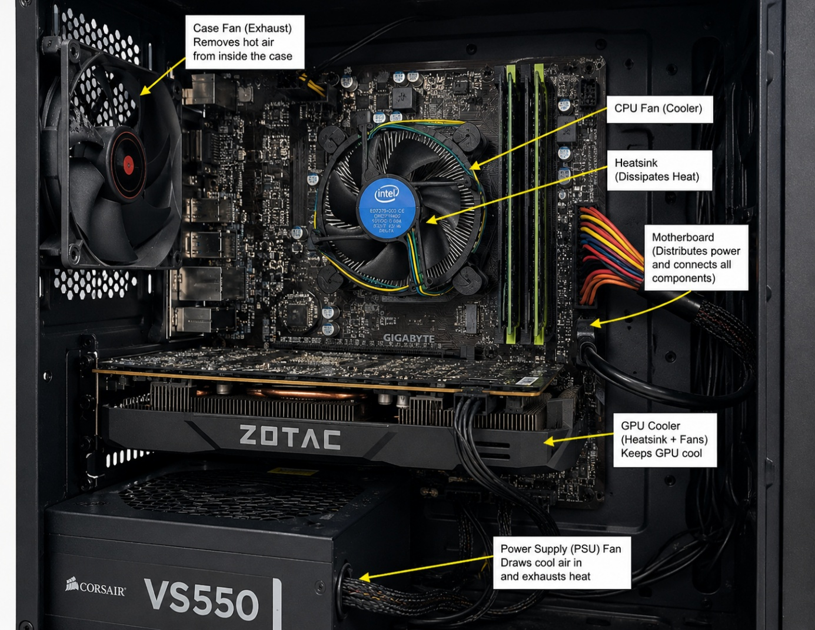
- Heatsink (Metal Fins): Soaks up heat directly from the hot graphics chip.
- Cooling Fans: Blows fresh air over the metal fins to push heat away.
- Thermal Paste / Pads: A soft paste placed between the chip and heatsink to help heat transfer smoothly without trapped air.
- Backplate & Shroud: The outer cover that directs airflow and protects the circuit board.

Task 3: Air Cooling vs. Liquid Cooling

Feature | Air Cooling | Liquid Cooling
Cost | Cheaper and comes pre-installed on most cards. | More expensive because of extra tubes, pumps, and liquid parts.
Cooling & Noise | Good for normal gaming, but fans can get loud under heavy load. | Cools better and stays much quieter during long sessions.
Maintenance | Very easy; just blow out the dust. | Needs more care to prevent pump wear or liquid leaks over time.
Installation | Easy; just plug the card into the motherboard. | Needs extra space inside the case to mount the radiator and tubes.

Task 4: Choice for Gaming & Streaming

I choose Liquid Cooling to building a gaming PC for streaming IPL matches and playing graphics-heavy games. Streaming live video while running heavy games puts constant pressure on the GPU, creating high heat that liquid cooling handles much better. It also keeps the system quiet, preventing loud fan noise from getting picked up by the stream microphone. In addition, it pushes heat directly out of the PC case so the computer stays cool during long streaming sessions.

